

AMRITA SCHOOL OF ENGINEERING, BANGALORE
AMRITA VISHWA VIDYAPEETHAM
BANGALORE 560 035

REGISTRATION PORTAL FOR JAVA COURSE

A PROJECT REPORT

Submitted by

BL.EN.U4AIE19014 CHAVALI SURYA TEJA

For the subject

19AIE111- Data Structures and Algorithms -1

Faculty Incharge
Ms. D. Radha
Asst. Prof(SG),
CSE, ASE-BLR

DESCRIPTION OF THE PROJECT

This project is an Application Portal for the registration of a JAVA course. This project has been done using the Linked Lists Data structure. Java’s built-in class for Linked Lists has been used here. It mainly consists of 3 classes –

- Candidate_Registration_Number,

- Candidate_Registration_Number_GUI

The GUI consists of two text fields, namely:

- Name
- Mobile Number

And several other options, such as Add Candidate, Delete Candidate, Edit the details of a Candidate, then saving them, Display the list of candidates, and finally the exit option.

The above all are implemented using Linked Lists.

The rest of the details regarding it will be discussed in the later section.

EXPLANATION OF DATA STRUCTURE AND GUI

Data Structure:

The built-in Linked lists module has been imported and all the methods such as add (), remove (), etc., have been for options such as new entry for a candidate and deleting a candidate, etc...

The linked list has been declared private and the data from Candidate_Registration_Number class is being passed on to the linked list as objects and it stores them.

The code looks like this :

private LinkedList<Candidate_Registration_Number> CandidateLinkedList = new LinkedList<Candidate_Registration_Number> ();

The imported linked list has been initialized to ‘Candidate_Registration_Number. Then we are going to implement an ActionListener for the add button, and the code for the same is given below:

addButton.addActionListener (event -> Add_Candidate ());

The arrow operator (->) specifies a member of a struct (or a member of a class object) that is pointed to by a pointer variable.

Similarly we do it for all buttons and we initialize their respective action listeners which are the :

addButton.addActionListener (event -> Add_Candidate ());
displayAllButton.addActionListener (event -> Display_All ());
editButton.addActionListener (event -> Edit_Candidate ());
editSaveButton.addActionListener (event -> Edit_Save_Candidate ());
exitButton.addActionListener (event -> Exit_Application ());
deleteButton.addActionListener (event -> Delete_Candidate ());

GUI:

Coming to the GUI part,

we first declare all the required GUI components which are the JTextArea, JTextFields, JLabels, JPanels, JOptionPane.

After that, first, we split the registration portal window to 2 flow panel and one main grid panel.

Then, we initialize the text area, where all the details of the candidates are printed.

Then, we create three JLabel’s – icon, NameLabel, and MobileNumberLabel respectively.

Then proceeding on to the text fields, two text fields corresponding to Name and Mobile Number have been initialized, which are – NameTextField and MobileNumberTextField.

Looking at the buttons,

six JButtons have been created to perform some actions corresponding to the data stored in the Linked List and their respective action listeners have been initialized, as discussed previously.

After that, these buttons, labels, and text fields are added to the flow panels depending on our perspective of the GUI, and finally, we add these two flow panels to the main grid panel.

We then add different kinds of attributes to the GUI like :

- Adding a Background color to the Flow panels and the buttons.

- Setting the font size and color to the text area, labels, text fields, and the buttons.

- We can even add images as passing them as objects into the JLabels.

- And finally aligning these using the functions such as BorderLayout.CENTER, FlowLayout.SOUTH, etc., according to our simplicity.

Finally, in the main class, we set the applet’s location, size, and visibility as true.
CODE

(Class wise)

Candidate_Registration_Number:

import javax.swing.*;
public class Candidate_Registration_Number
{
public static final String Reg_No = "BL.EN.U4AIE_JAVA_";
private String name;
private String mobile_number;
public Candidate_Registration_Number ()
{
name = "";
mobile_number = "";
}
public Candidate_Registration_Number (String mobile_number, String name)
{
// Remove spaces
name = name.trim ();
mobile_number = mobile_number.trim ();
if (name.length () == 0)
{
JOptionPane.showMessageDialog (null, "Error: name cannot be blank.");
}
else if (mobile_number.length () == 0)
{
JOptionPane.showMessageDialog (null, "Error: name cannot be blank.");
else
{
// We set class data to the values passed in.
this.name = name;
this.mobile_number = mobile_number;
}
}
public String getName ()
{
return name;
}
public String getMobile_number ()
{
return mobile_number;
}
public void setName (String name)
{
this.name = name;
}
public void setMobile_number (String mobile_number)
{
this.mobile_number = mobile_number;
}
@Override
public String toString ()
{
return mobile_number + "\t" + name + "\t" + Reg_No + name;
}
}

Candidate_Registration_Number_GUI:

import javax.swing.*;
import java.awt.*;
import java.awt.event.WindowAdapter;
import java.awt.event.WindowEvent;
import java.util.LinkedList;
public class Candidate_Registration_Numbers_GUI extends JFrame
{
// GUI Components:
JTextArea Candidate_Details = new JTextArea ();
ImageIcon image = new ImageIcon("image.jpg");
JLabel icon = new JLabel(image);
JLabel NameLabel = new JLabel (" Name : ");
JTextField NameTextField = new JTextField (10);
JLabel MobileNumberLabel = new JLabel (" Mobile Number : ");
JTextField MobileNumberTextField = new JTextField (10);
JButton addButton = new JButton (" Add ");
JButton deleteButton = new JButton (" Delete ");
JButton editButton = new JButton (" Edit ");
JButton editSaveButton = new JButton (" Save ");
JButton displayAllButton = new JButton (" Display All ");
JButton exitButton = new JButton (" Exit ");
// Class Instance Data:
private LinkedList<Candidate_Registration_Number> CandidateLinkedList = new LinkedList<Candidate_Registration_Number> ();
private int editIndex;
public Candidate_Registration_Numbers_GUI ()
{
JOptionPane.showMessageDialog(Candidate_Registration_Numbers_GUI.this,
" Welcome to Online Java Course Registration \uD83D\uDE03 \uD83D\uDE03 \uD83D\uDE03 \n\n"
+ "Created by Ch. Surya Teja\n\n"
+ "Instructions for the porcess :\n\n"
+ " 1.) Enter the Candidate's name. \n"
+ " 2.) Enter His/Her respective Mobile number. \n"
+ " 3.) And then, they'll be getting their Registration Number. \n"
+ " 4.) You can also delete any entry. \n"
+ " 5.) You can edit the inputs. \n"
+ " 6.) You can always display all the candidate's lists if you've lost track. \n"
+ " 7.) After you've done, click exit to exit the app.\n\n"
+ " Hope you like it ! \n");
JPanel flow1Panel = new JPanel (new FlowLayout (FlowLayout.CENTER));
JPanel flow2Panel = new JPanel (new FlowLayout (FlowLayout.CENTER));
JPanel gridPanel = new JPanel (new GridLayout (2, 3));
Candidate_Details.setEditable (false);
NameLabel.setForeground(Color.blue);
MobileNumberLabel.setForeground(Color.blue);
Font f1 = new Font("Arial",Font.BOLD,20);
NameLabel.setFont(f1);
addButton.setBackground(Color.green);
deleteButton.setBackground(Color.green);
editButton.setBackground(Color.green);
editSaveButton.setBackground(Color.green);
displayAllButton.setBackground(Color.green);
exitButton.setBackground(Color.green);
Font f2= new Font("Arial",Font.BOLD, 17);
MobileNumberLabel.setFont(f2);
Font f3 = new Font("Arial", Font.BOLD, 13);
MobileNumberTextField.setFont(f3);
Font f4 = new Font("Arial", Font.BOLD, 14);
NameTextField.setFont(f4);
Candidate_Details.setBackground(Color.ORANGE);
Candidate_Details.setForeground(Color.red);
flow1Panel.add (NameLabel);
flow1Panel.add (NameTextField);
flow1Panel.add (MobileNumberLabel);
flow1Panel.add (MobileNumberTextField);
flow1Panel.setBackground(Color.PINK);
flow2Panel.add (addButton);
flow2Panel.add (editButton);
flow2Panel.add (editSaveButton);
flow2Panel.add (deleteButton);
flow2Panel.add (displayAllButton);
flow2Panel.add (exitButton);
flow2Panel.setBackground(Color.PINK);
gridPanel.add (flow1Panel);
gridPanel.add (flow2Panel);
gridPanel.add(icon);
gridPanel.setBackground(Color.PINK);
editSaveButton.setEnabled (false);
add (Candidate_Details, BorderLayout.CENTER);
add (gridPanel, BorderLayout.SOUTH);
icon.setBounds(100,50,50,50);
addButton.addActionListener (event -> Add_Candidate ());
displayAllButton.addActionListener (event -> Display_All ());
editButton.addActionListener (event -> Edit_Candidate ());
editSaveButton.addActionListener (event -> Edit_Save_Candidate ());
exitButton.addActionListener (event -> Exit_Application ());
deleteButton.addActionListener (event -> Delete_Candidate ());
setTitle (" Online Registration Portal for Java Course ! ");
addWindowListener(new WindowAdapter() {
public void windowClosing(WindowEvent e) {
int confirmed = JOptionPane.showConfirmDialog(null,
" Are you sure you want to exit the program? ", " Exit Program Message Box ",
JOptionPane.YES_NO_OPTION);
if (confirmed == JOptionPane.YES_OPTION) {
dispose();
}
}
});
}
private boolean isCandidate_number_In_LinkedList (String NameStr)
{
boolean inList = false;
for (Candidate_Registration_Number Cand : CandidateLinkedList)
{
if (Cand.getName ().compareToIgnoreCase (NameStr) == 0)
{
inList = true;
}
}
return inList;
}
private void Add_Candidate ()
{
if (isCandidate_number_In_LinkedList ( MobileNumberTextField.getText()) == true)
{
JOptionPane.showMessageDialog (Candidate_Registration_Numbers_GUI.this,
"Error: This Mobile Number has already been take in the DataBase.");
}
else
{
Candidate_Registration_Number Cand = new Candidate_Registration_Number (NameTextField.getText(),
MobileNumberTextField.getText());
CandidateLinkedList.add (Cand);
Display_All ();
MobileNumberTextField.setText("");
NameTextField.setText("");
}
}
private void Delete_Candidate ()
{
if (CandidateLinkedList.size() == 0)
{
JOptionPane.showMessageDialog (Candidate_Registration_Numbers_GUI.this,
"Error: Database is empty.");
}
else if (isCandidate_number_In_LinkedList (MobileNumberTextField.getText()) == false)
{
JOptionPane.showMessageDialog (Candidate_Registration_Numbers_GUI.this,
"Error: Candidate's Mobile number is not in the database.");
}
else
{
for (int s = 0; s < CandidateLinkedList.size(); s++)
{
String currMN = CandidateLinkedList.get (s).getName ();
if (currMN.compareToIgnoreCase (MobileNumberTextField.getText()) == 0)
{
CandidateLinkedList.remove (s);
}
}
Display_All ();
MobileNumberTextField.setText("");
NameTextField.setText("");
}
}
private void Edit_Candidate ()
{
if (CandidateLinkedList.size() == 0)
{
JOptionPane.showMessageDialog (Candidate_Registration_Numbers_GUI.this,
"Error: Database is empty.");
}
else if (isCandidate_number_In_LinkedList (MobileNumberTextField.getText()) == false)
{
JOptionPane.showMessageDialog (Candidate_Registration_Numbers_GUI.this,
"Error: Candidate's Mobile number is not in the database.");
}
else
{
editIndex = -1;
for (int s = 0; s < CandidateLinkedList.size(); s++)
{
String currId = CandidateLinkedList.get (s).getName ();
if (currId.compareToIgnoreCase (MobileNumberTextField.getText()) == 0)
{
editIndex = s;
s = CandidateLinkedList.size(); // Exit Loop
}
}
// index cannot be less than 0, because we checked if the Cand Id was in
// the linked list before we looped above.
if (editIndex >= 0)
{
editSaveButton.setEnabled (true);
editButton.setEnabled (false);
addButton.setEnabled (false);
deleteButton.setEnabled (false);
displayAllButton.setEnabled (false);
exitButton.setEnabled (false);
MobileNumberTextField.setText (CandidateLinkedList.get (editIndex).getName () );
}
}
}
private void Edit_Save_Candidate ()
{
// This code will preserve the changes the user made to the Candidate
// they were editing - and save them back into the Linked List.
CandidateLinkedList.get (editIndex).setName (MobileNumberTextField.getText() );
CandidateLinkedList.get (editIndex).setMobile_number (NameTextField.getText() );
Display_All ();
MobileNumberTextField.setText ("");
NameTextField.setText ("");
editSaveButton.setEnabled (false);
editButton.setEnabled (true);
addButton.setEnabled (true);
deleteButton.setEnabled (true);
displayAllButton.setEnabled (true);
exitButton.setEnabled (true);
}
private void Display_All ()
{
Font f = new Font("Arial",Font.BOLD,19);
Candidate_Details.setText ("");
Candidate_Details.setFont(f);
for (Candidate_Registration_Number Cand : CandidateLinkedList)
{
Candidate_Details.append (Cand + "\n");
}
}
private void Exit_Application ()
{
System.exit (0);
}
public static void main (String[] args)
{
Candidate_Registration_Numbers_GUI app = new Candidate_Registration_Numbers_GUI ();
app.setVisible (true);
app.setSize (1000, 500);
app.setLocation (200, 100);
app.setDefaultCloseOperation (JFrame.EXIT_ON_CLOSE);
}
}

SAMPLE SNAPSHOTS OF THE OUTPUT
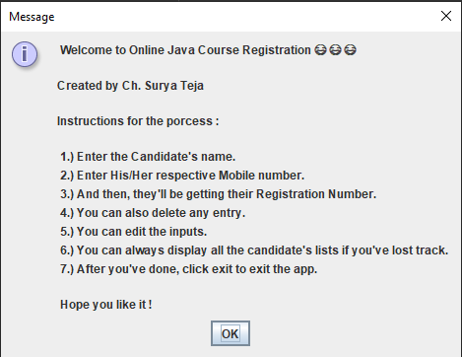

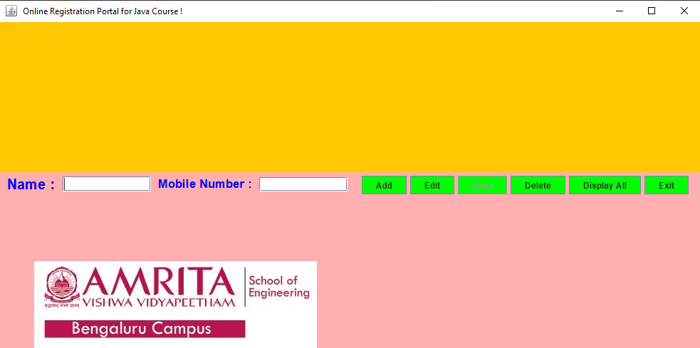
(Welcoming Screen)
(Empty screen with all options)
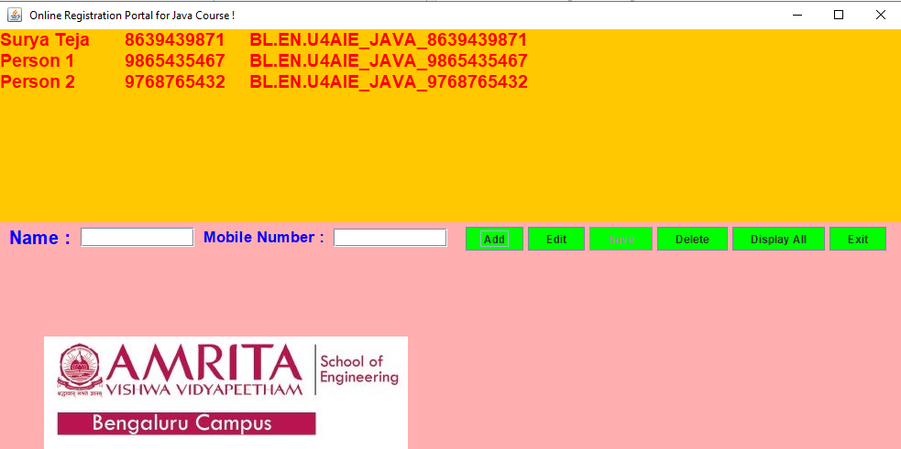
(Candidate’s details in the Text Area)
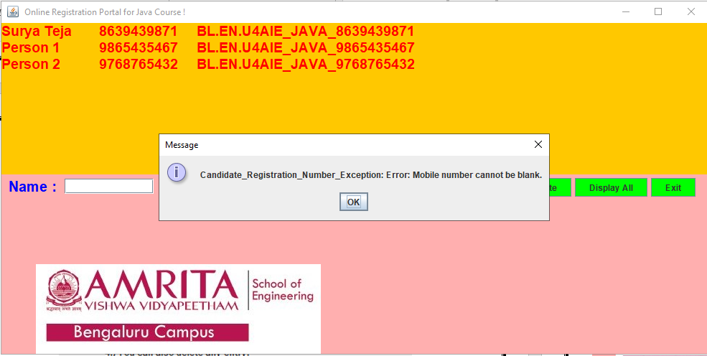

(If the Add button is clicked, with the empty name field, a message pops up, and same goes with an empty mobile number field)
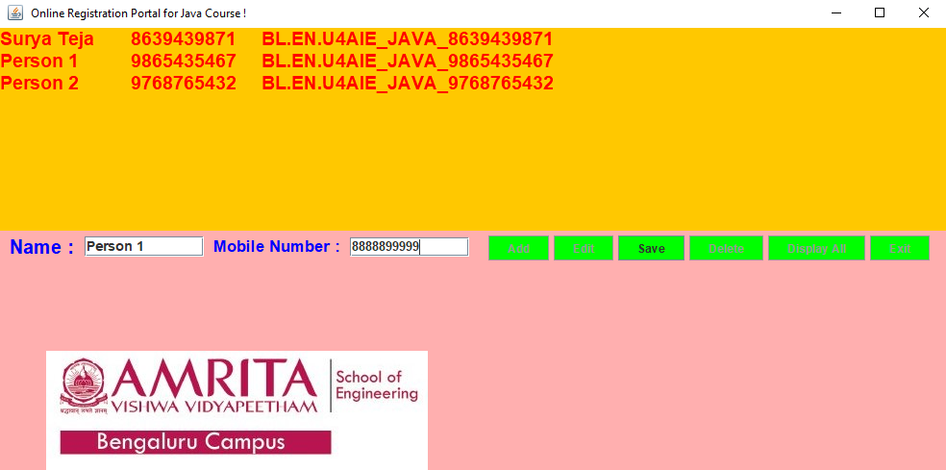
(Upon clicking edit, we can edit the credentials, with all other buttons disabled, except Save button)
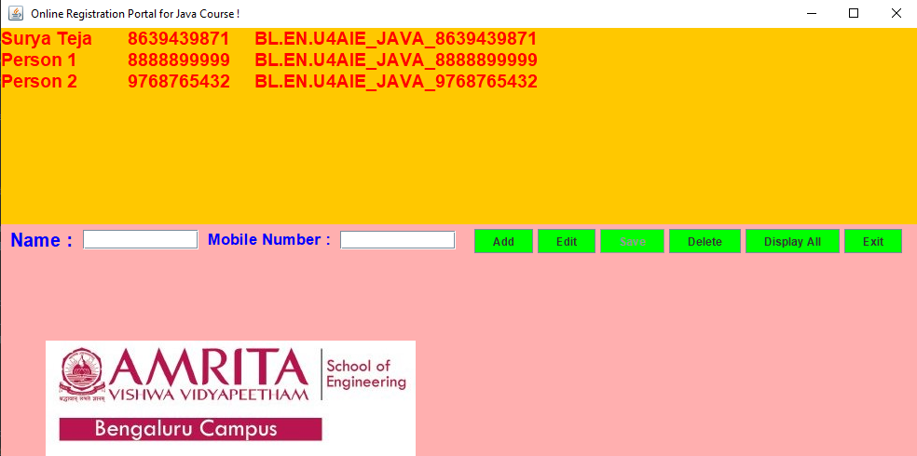

(After clicking Save, the list gets updated)

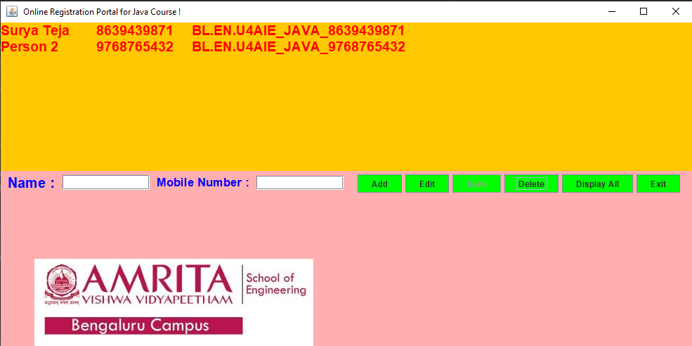
(After entering the desired name and then if the delete button is clicked, the candidate’s details gets deleted)
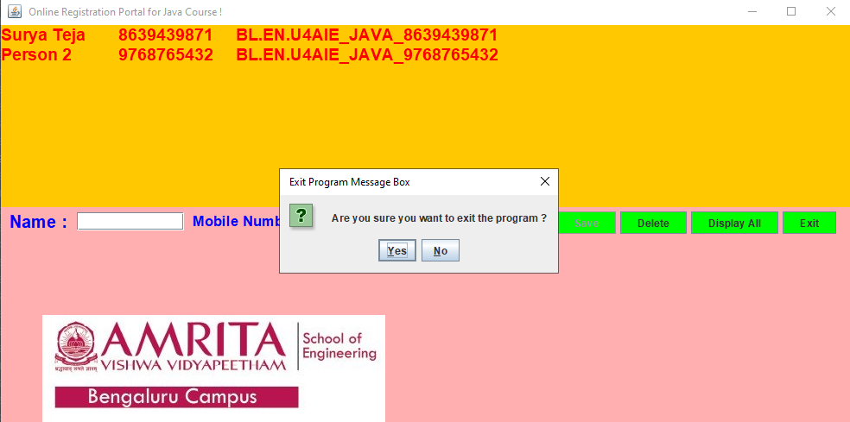

(And, finally a Yes/No option pops upon clicking the close button)

